“Perhaps a Nietzsche K”

1NC 1-7
LINKS
Suffering 8-11
Morals 12-14
Utilitarian 15-18
Democracy 19
IMPACTS
Self First 20
Prefer Destruction 21
Will to Nothing 22
Violence/Value to Life 23-25
Justify Existence 26-27
Exemplar key to Progress 28
ALTERNATIVE
Reject Community/Individualism 29-30
Question Security 31
FRAMEWORK 32
AT
AT- Nietzsche = Tyranny 33
AT- Feminism 34
AT- Exclusion Bad 35
AT- Your Evil 36
AT- Util 37-38

AFF
Death Worse 39
Genocide 40

Friedrich Nietzsche, not a man but dynamite, 1886, Beyond Good and Evil, numb 41

One must subject oneself to one's own tests that one is destined for independence and command, and do so at the right time. One must not avoid one's tests, although they constitute perhaps the most dangerous game one can play, and are in the end tests made only before ourselves and before no other judge. Not to cleave to any person, be it even the dearest—every person is a prison and also a recess. Not to cleave to a fatherland, be it even the most suffering and necessitous—it is even less difficult to detach one's heart from a victorious fatherland. Not to cleave to a sympathy, be it even for higher men, into whose peculiar torture and helplessness chance has given us an insight. Not to cleave to a science, though it tempt one with the most valuable discoveries, apparently specially reserved for us. Not to cleave to one's own liberation, to the voluptuous distance and remoteness of the bird, which always flies further aloft in order always to see more under it—the danger of the flier. Not to cleave to our own virtues, nor become as a whole a victim to any of our specialties, to our “hospitality” for instance, which is the danger of dangers for highly developed and wealthy souls, who deal prodigally, almost indifferently with themselves, and push the virtue of liberality so far that it becomes a vice. One must know how TO CONSERVE ONESELF—the best test of independence.
1NC

The affirmatives attempt to rationalize and stabilize a chaotic world- in its prevention of chaos and suffering, the affirmative goes on a constant search for what is inherently true in the world, IE the will to truth.

Paul Saurette, Prof Political Theory at John Hopkins University, 1996, "I Mistrust all Systematizers and Avoid Them': Nietzsche, Arendt and Crisis of the Will to Order in International Relations Theory", Journa of International Studies, Vol. 25 No. 1 pp.1-28

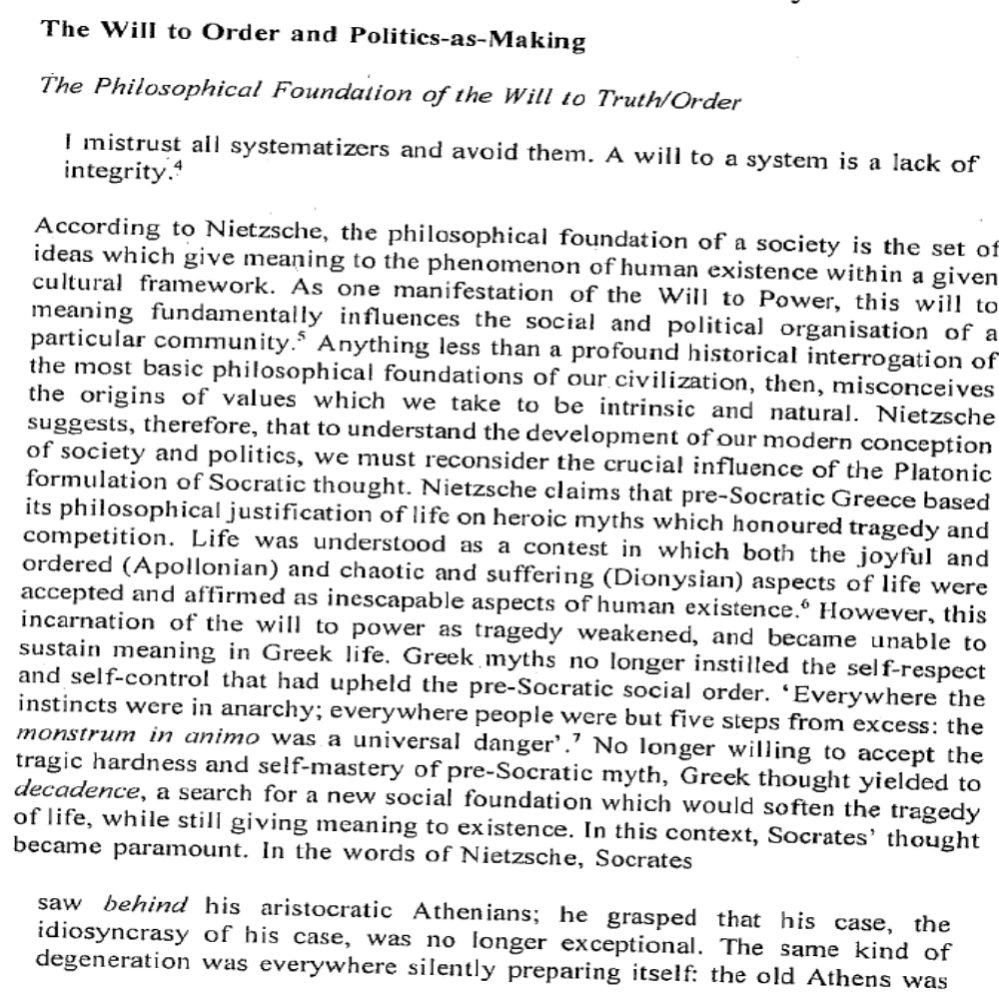

1NC

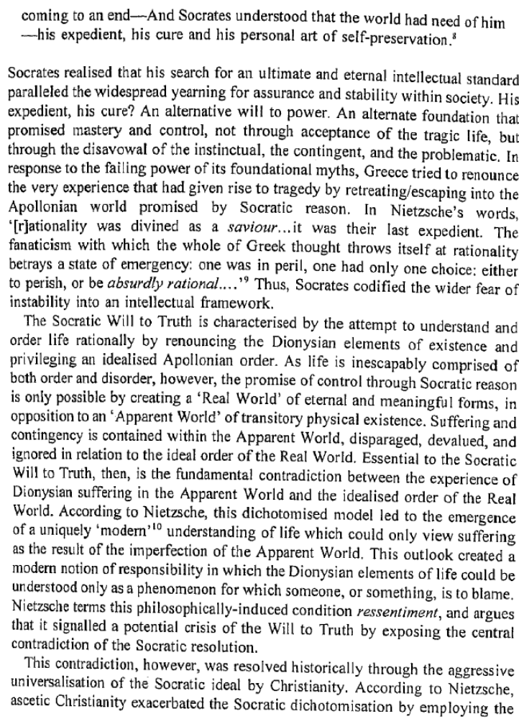

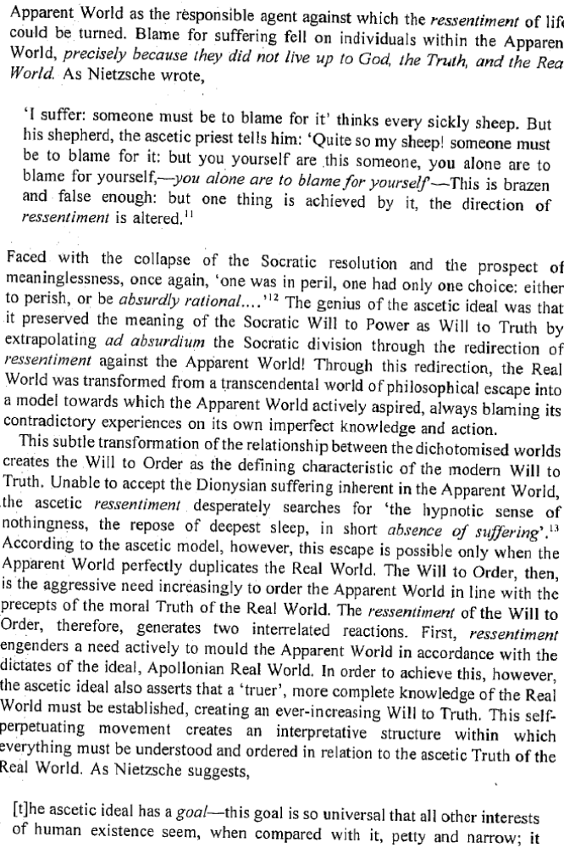
1NC
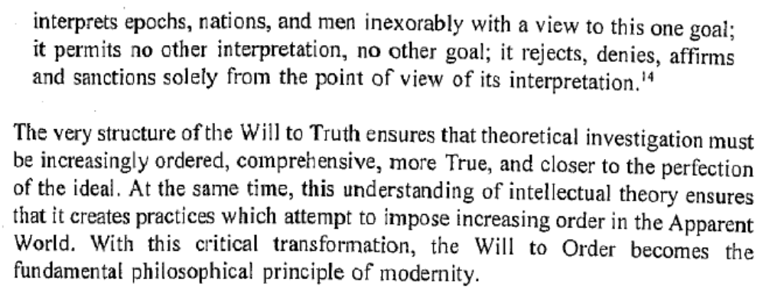
1NC

The will to truth can only lead to destruction- systematically killing off every new idol eventually turning inward- absent alternative extinction is inevitable.

Paul Saurette, Prof Political Theory at John Hopkins University, 1996, "I Mistrust all Systematizers and Avoid Them': Nietzsche, Arendt and Crisis of the Will to Order in International Relations Theory", Journa of International Studies, Vol. 25 No. 1 pp.1-28

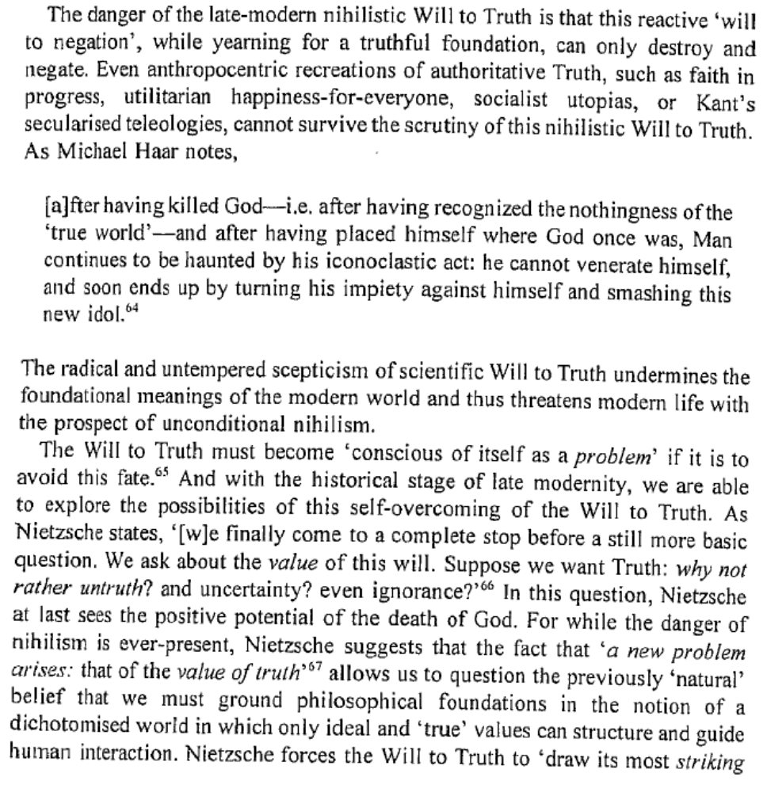
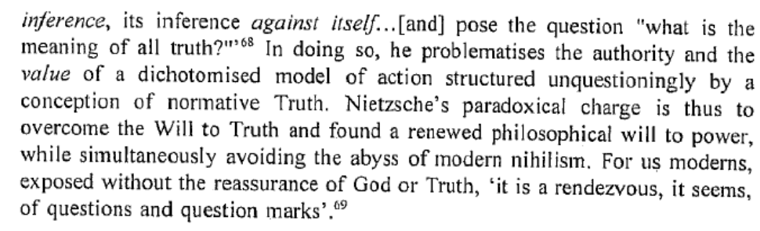
1NC

Nihilism is inevitable- only experiencing nihilism can we escape the current value system and embrace new values.

Friedrich Nietzsche, not a man but dynamite, 1887, “Preface”, Will to Power, numb. 1-4

What I relate is the history of the next two centuries. I describe what is coming, what can no longer come differently: the advent of nihilism. This history can be related even now; for necessity itself is at work here. This future speaks even now in a hundred signs, this destiny announces itself everywhere; for this music of the future all ears are cocked even now. For some time now, our whole European culture has been moving as toward a catastrophe, with a tortured tension that is growing from decade to decade: restlessly, violently, headlong, like a river that wants to reach the end, that no longer reflects, that is afraid to reflect.
He that speaks here, conversely, has done nothing so far but reflect: a philosopher and solitary by instinct, who has found his advantage in standing aside and outside, in patience, in procrastination, in staying behind; as a spirit of daring and experiment that has already lost its way once in every labyrinth of the future; as a soothsayer-bird spirit who looks back when relating what will come; as the first perfect nihilist of Europe who, however, has even now lived through the whole of nihilism, to the end, leaving it behind, outside himself.
For one should make no mistake about the meaning of the title that this gospel of the future wants to bear. "The Will to Power: Attempt at a Revaluation of All Values"--in this formulation a countermovement finds expression, regarding both principle and task; a movement that in some future will take the place of this perfect nihilism--but presupposes it, logically and psychologically, and certainly can come only after and out of it. For why has the advent of nihilism become necessary? Because the values we have had hitherto thus draw their final consequence; because nihilism represents the ultimate logical conclusion of our great values and ideals--because we must experience nihilism before we can find out what value these "values" really had.--We require, sometime, new values.
Links- Suffering

The attempt to prevent suffering makes us all slaves to the so called good natured freedom.

Friedrich Nietzsche, not a man but dynamite, 1886, Beyond Good and Evil, numb 260

Supposing that the abused, the oppressed, the suffering, the unemancipated, the weary, and those uncertain of themselves should moralize, what will be the common element in their moral estimates? Probably a pessimistic suspicion with regard to the entire situation of man will find expression, perhaps a condemnation of man, together with his situation. The slave has an unfavourable eye for the virtues of the powerful; he has a skepticism and distrust, a REFINEMENT of distrust of everything “good” that is there honoured—he would fain persuade himself that the very happiness there is not genuine. On the other hand, THOSE qualities which serve to alleviate the existence of sufferers are brought into prominence and flooded with light; it is here that sympathy, the kind, helping hand, the warm heart, patience, diligence, humility, and friendliness attain to honour; for here these are the most useful qualities, and almost the only means of supporting the burden of existence. Slave−morality is essentially the morality of utility. Here is the seat of the origin of the famous antithesis “good” and “evil”:—power and dangerousness are assumed to reside in the evil, a certain dreadfulness, subtlety, and strength, which do not admit of being despised. According to slave−morality, therefore, the “evil” man arouses fear; according to master−morality, it is precisely the “good” man who arouses fear and seeks to arouse it, while the bad man is regarded as the despicable being. The contrast attains its maximum when, in accordance with the logical consequences of slave−morality, a shade of depreciation—it may be slight and well−intentioned—at last attaches itself to the “good" man of this morality; because, according to the servile mode of thought, the good man must in any case be the SAFE man: he is good−natured, easily deceived, perhaps a little stupid, un bonhomme. Everywhere that slave− morality gains the ascendancy, language shows a tendency to approximate the significations of the words “good” and “stupid.”−—A last fundamental difference: the desire for FREEDOM, the instinct for happiness and the refinements of the feeling of liberty belong as necessarily to slave−morals and morality, as artifice and enthusiasm in reverence and devotion are the regular symptoms of an aristocratic mode of thinking and estimating.— Hence we can understand without further detail why love AS A PASSION—it is our European specialty—must absolutely be of noble origin; as is well known, its invention is due to the Provencal poet−cavaliers, those brilliant, ingenious men of the “gai saber,” to whom Europe owes so much, and almost owes itself.
Links- Suffering
We have an obligation to break free of our current assumption of suffering must be resisted and the mass promotion of human rights as being championed by the assumption of a necessary truth.
Friedrich Nietzsche, not a man but dynamite, 1886, Beyond Good and Evil, numb 44
Need I say expressly after all this that they will be free, VERY free spirits, these philosophers of the future—as certainly also they will not be merely free spirits, but something more, higher, greater, and fundamentally different, which does not wish to be misunderstood and mistaken? But while I say this, I feel under OBLIGATION almost as much to them as to ourselves (we free spirits who are their heralds and forerunners), to sweep away from ourselves altogether a stupid old prejudice and misunderstanding, which, like a fog, has too long made the conception of “free spirit” obscure. In every country of Europe, and the same in America, there is at present something which makes an abuse of this name a very narrow, prepossessed, enchained class of spirits, who desire almost the opposite of what our intentions and instincts prompt—not to mention that in respect to the NEW philosophers who are appearing, they must still more be closed windows and bolted doors. Briefly and regrettably, they belong to the LEVELLERS, these wrongly named “free spirits”—as glib−tongued and scribe−fingered slaves of the democratic taste and its “modern ideas" all of them men without solitude, without personal solitude, blunt honest fellows to whom neither courage nor honourable conduct ought to be denied, only, they are not free, and are ludicrously superficial, especially in their innate partiality for seeing the cause of almost ALL human misery and failure in the old forms in which society has hitherto existed—a notion which happily inverts the truth entirely! What they would fain attain with all their strength, is the universal, green−meadow happiness of the herd, together with security, safety, comfort, and alleviation of life for every one, their two most frequently chanted songs and doctrines are called “Equality of Rights" and “Sympathy with All Sufferers”—and suffering itself is looked upon by them as something which must be DONE AWAY WITH. We opposite ones, however, who have opened our eye and conscience to the question how and where the plant “man” has hitherto grown most vigorously, believe that this has always taken place under the opposite conditions, that for this end the dangerousness of his situation had to be increased enormously, his inventive faculty and dissembling power (his “spirit") had to develop into subtlety and daring under long oppression and compulsion, and his Will to Life had to be increased to the unconditioned Will to Power—we believe that severity, violence, slavery, danger in the street and in the heart, secrecy, stoicism, tempter's art and devilry of every kind,—that everything wicked, terrible, tyrannical, predatory, and serpentine in man, serves as well for the elevation of the human species as its opposite—we do not even say enough when we only say THIS MUCH, and in any case we find ourselves here, both with our speech and our silence, at the OTHER extreme of all modern ideology and gregarious desirability, as their anti−podes perhaps? What wonder that we “free spirits” are not exactly the most communicative spirits? That we do not wish to betray in every respect WHAT a spirit can free itself from, and WHERE perhaps it will then be driven? And as to the import of the dangerous formula, “Beyond Good and Evil,” with which we at least avoid confusion, we ARE something else than “libres−penseurs,” “liben pensatori" “free−thinkers,” and whatever these honest advocates of “modern ideas" like to call themselves. Having been at home, or at least guests, in many realms of the spirit, having escaped again and again from the gloomy, agreeable nooks in which preferences and prejudices, youth, origin, the accident of men and books, or even the weariness of travel seemed to confine us, full of malice against the seductions of dependency which he concealed in honours, money, positions, or exaltation of the senses, grateful even for distress and the vicissitudes of illness, because they always free us from some rule, and its “prejudice,” grateful to the God, devil, sheep, and worm in us, inquisitive to a fault, investigators to the point of cruelty, with unhesitating fingers for the intangible, with teeth and stomachs for the most indigestible, ready for any business that requires sagacity and acute senses, ready for every adventure, owing to an excess of “free will", with anterior and posterior souls, into the ultimate intentions of which it is difficult to pry, with foregrounds and backgrounds to the end of which no foot may run, hidden ones under the mantles of light, appropriators, although we resemble heirs and spendthrifts, arrangers and collectors from morning till night, misers of our wealth and our full−crammed drawers, economical in learning and forgetting, inventive in scheming, sometimes proud of tables of categories, sometimes pedants, sometimes night−owls of work even in full day, yea, if necessary, even scarecrows.

Links- Prevent Suffering

The attempt to prevent suffering is disastrous`- suffering is the art at which humans excel.

Daniel Conway, Professor and Department Head 19th Century Philosophy at Texas A&M, 1997, Nietzsche and the Political, pg. 89

Because self-overcoming presupposes suffering, any attempt to “abolish” suffering in the name of “modern ideas” would spell disaster (BGE 44). Suffering is furthermore the art at which human animals excel most resoundingly. All that is valuable within the “circle of culture” represents the spiritualization of cruelty. Lest we disable the engine of moral progress, then, Nietzsche urges us not to indulge our pity” for
”the creature in man,” for what must be formed, broken, forged, torn, burnt, made incandescent and purified-that which necessarily must and should suffer” (BGE 225). Genuine Erziehung is both painful and dangerous, provoking and eliciting the uncharted plasticities of the human soul. Rather than abolish suffering, we must continue to fashion interpretive contexts in which the suffering endemic to self-overcoming becomes meaningful and sublime. For this reason, the ascetic, or saint, plays a central role in the founding of culture.
Link- Morals- Destroys Personal Sovereignty

The affirmatives call to morals becomes a self disciplining norm that destroys any personal sovereignty.

Daniel Conway, Professor and Department Head 19th Century Philosophy at Texas A&M, 1997, Nietzsche and the Political, pg. 19

For all of his enthusiasm, however, the cultural production of sovereign individuals is simply incompatible with the diminished resources at the disposal of his age. What modernity calls an “individual,” the pride of the Enlightenment, is nothing more than a “moral milksop,” a domesticated animal that has internalized the demands of culture and consequently operates under the illusion of self-legislated freedom. Even the sovereign individual,” who possesses “the right to make promises,” owes his ”rare freedom” to his “conscience,” which, Nietzsche shows, is itself an implant of socially enforced heteronomy (GM 2: 2). The conscience, a fiercely vigilant homunculus responsible for reckoning one’s debts and obligations, represents the final-and most forbidding-barrier to genuine sovereignty.
Nietzsche snickers at the idea that the right to make promises stands as sufficient evidence of one’s sovereignty, for he views the conscience as the internalized, mnemonic distillation of socially enforced punitive and carceral practices. Whereas the noble savage and blond beast require sturdy cages or constant external surveillance, “men of conscience” are sufficiently docile to police themselves. Even Nietzsche himself, the self-styled immoralist and Antichrist, continues to wear this “venerable long pigtail,” which makes him “seem old-fashioned and grandfatherly-honorable” (BGE 214).
The closest thing we know to genuine, supramoral sovereignty is not the debt-paying, promise-keeping, originally positioned author of the social contract, but the criminal, the monster devoid of conscience, who personally shoulders the entire burden of his existential suffering. Nietzsche thus defines “the criminal type” as “the type of strong human being under unfavorable circumstances: a strong human being made sick” (TI 1X: 45).
Under the influence of Christianity, the institutions of Western civilization have for the most part implemented what Nietzsche calls “moralities of taming” (TI VII: 3). Social practices of self-formation have succeeded in sickening (and thus domesticating) those individals whose “virtues are ostracized by society.” The conscience thus prevents individuals from straying far from the internalized norm, while the institutions of modernity marginalize or stamp out those singular, exotic plants that do manage to blossom. On a rare occasion, however, “a man proves stronger than society: the Corsican, Napoleon, is the most famous case” (TI 1X: 45).
Links- Morality

Morality bases itself on a self promoting truth- that good is good because its useful and bad is bad because it is stupid to do wrong.

Friedrich Nietzsche, not a man but dynamite, 1886, Beyond Good and Evil, numb 190

There is something in the morality of Plato which does not really belong to Plato, but which only appears in his philosophy, one might say, in spite of him: namely, Socratism, for which he himself was too noble. “No one desires to injure himself, hence all evil is done unwittingly. The evil man inflicts injury on himself; he would not do so, however, if he knew that evil is evil. The evil man, therefore, is only evil through error; if one free him from error one will necessarily make him—good.”—This mode of reasoning savours of the POPULACE, who perceive only the unpleasant consequences of evil−doing, and practically judge that “it is STUPID to do wrong”; while they accept “good” as identical with “useful and pleasant,” without further thought. As regards every system of utilitarianism, one may at once assume that it has the same origin, and follow the scent: one will seldom err.— Plato did all he could to interpret something refined and noble into the tenets of his teacher, and above all to interpret himself into them—he, the most daring of all interpreters, who lifted the entire Socrates out of the street, as a popular theme and song, to exhibit him in endless and impossible modifications —namely, in all his own disguises and multiplicities. In jest, and in Homeric language as well, what is the Platonic Socrates, if not—[Greek words inserted here.]
Links- Morality

Morality forces the forcing of the presumption that morality must be good- leading to personal self contempt.

Friedrich Nietzsche, not a man but dynamite, 1886, Beyond Good and Evil, numb 221-222

221 “It sometimes happens,” said a moralistic pedant and trifle−retailer, “that I honour and respect an unselfish man: not, however, because he is unselfish, but because I think he has a right to be useful to another man at his own expense. In short, the question is always who HE is, and who THE OTHER is. For instance, in a person created and destined for command, self− denial and modest retirement, instead of being virtues, would be the waste of virtues: so it seems to me. Every system of unegoistic morality which takes itself unconditionally and appeals to every one, not only sins against good taste, but is also an incentive to sins of omission, an ADDITIONAL seduction under the mask of philanthropy—and precisely a seduction and injury to the higher, rarer, and more privileged types of men. Moral systems must be compelled first of all to bow before the GRADATIONS OF RANK; their presumption must be driven home to their conscience—until they thoroughly understand at last that it is IMMORAL to say that 'what is right for one is proper for another.'”—So said my moralistic pedant and bonhomme. Did he perhaps deserve to be laughed at when he thus exhorted systems of morals to practise morality? But one should not be too much in the right if one wishes to have the laughers on ONE'S OWN side; a grain of wrong pertains even to good taste.
222. Wherever sympathy (fellow−suffering) is preached nowadays— and, if I gather rightly, no other religion is any longer preached—let the psychologist have his ears open through all the vanity, through all the noise which is natural to these preachers (as to all preachers), he will hear a hoarse, groaning, genuine note of SELF−CONTEMPT. It belongs to the overshadowing and uglifying of Europe, which has been on the increase for a century (the first symptoms of which are already specified documentarily in a thoughtful letter of Galiani to Madame d'Epinay)—IF IT IS NOT REALLY THE CAUSE THEREOF! The man of “modern ideas,” the conceited ape, is excessively dissatisfied with himself−this is perfectly certain. He suffers, and his vanity wants him only “to suffer with his fellows.”
Links- Utili

Their utilitarian framework becomes slave morality- it destroys individual values and denies the necessity of suffering in the name of the herd.

Jonny Anomaly, Assistant Professor of Philosophy at Ithaca College, 2005, “Nietzsche's Critique of Utilitarianism”, http://muse.jhu.edu/journals/journal_of_nietzsche_studies/v029/29.1anomaly.html

What does it mean to espouse the values of a herd animal? We have already encountered some of the values Nietzsche associates with slave morality—humility, industriousness, pity, but in what sense are they "herd" values? If the fundamental goal of an animal within a herd is its own preservation, and if its own preservation depends upon the health of the herd of which it is a member, then, Nietzsche supposes, the moral principles of that group will tend to reflect the kind of egalitarianism embodied in Bentham's dictum, "Everybody counts for one, and nobody for more than one."7 Nietzsche considers this the essence of herd mentality: "[I]t is the instinct of the herd that finds its formula in this rule—one is equal, one takes oneself for equal" (WP 925). According to Nietzsche, this egalitarian formula originates from the benefit that comes from reciprocal cooperation among equals in a group, but has been extended by Christian morality to apply to all people—including unequals. Nietzsche thus construes the golden rule as a precept of "prudence" or mutual advantage, observing that "John Stuart Mill believes in it"as the basis of morality, but that he fails to grasp its prudential origin (WP 925).8
Nietzsche also portrays egalitarian values as myopic, dangerous, and potentially self-subverting. This is because, Nietzsche thinks, the opposite of these values—pain, suffering, inequality; in short, "evil"—is equally indispensable for the survival and happiness of the very herd that seeks to eradicate it. Accordingly, Nietzsche sharply criticizes Bentham's hedonic calculus (which correlates happiness maximization with pain minimization) as inconsistent with utilitarian goals. In its place, Nietzsche stresses the necessity of physical suffering and intellectual struggle for the self-improvement of each and, by extension, the vitality and happiness of the group. He accordingly rebukes the proponent of any morality that makes the reduction of suffering its fundamental goal: "[I]f you experience suffering and displeasure as evil, worthy of annihilation and as a defect of existence, then it is clear that besides your religion of pity you also harbor another religion in your heart that is perhaps the mother of the religion of pity: the religion of comfortableness" (GS 338). This religion—or, more specifically, morality—of comfort thwarts its own goals by attempting to eliminate all suffering (BGE 44).9 In a passage that anticipates what we now call the "hedonic paradox," according to which pleasure is diminished when we pursue it directly, Nietzsche ridicules those who, like Bentham, seek to maximize individual or collective happiness by minimizing pain: "[H]ow little you know of human happiness, you comfortable and benevolent people, for happiness and unhappiness are sisters and even twins that either grow up together or, as in your case, remain small together" (GS 338).10 He goes on to underline the idiosyncratic nature of suffering and the simplemindedness of those who heedlessly strive to relieve the suffering of others. "It never occurs to them," Nietzsche adds, "that ... the path to one's own heaven always leads through the voluptuousness of one's own hell" (GS 338).
Links- Util

Utilitarian fail to foresee the consequences their preventions- they fail to see that the “evils” they try to prevent are necessary for human advancement- and necessarily results in killing off of those not fit for the gene pool.

Jonny Anomaly, Assistant Professor of Philosophy at Ithaca College, 2005, “Nietzsche's Critique of Utilitarianism”, http://muse.jhu.edu/journals/journal_of_nietzsche_studies/v029/29.1anomaly.html

Nietzsche begins The Gay Science with the shocking statement, "Hatred, the mischievous delight in the misfortunes of others, the lust to rob and dominate, and whatever else is called evil belongs to the most amazing economy of the preservation of the species" (GS 1). In Beyond Good and Evil, he confirms that "everything evil, dreadful, tyrannical, beast of prey and serpent in man serves to enhance the species 'man' as much as does its opposite" (BGE 44).14 The careful way in which Nietzsche frames these passages indicates that he is not (straightforwardly) advocating what the powerless consider evil, but highlighting how their own continued existence as part of the human species depends upon the very aspects of existence they denounce as "evil." The utilitarians he criticizes allegedly accept the Darwinian idea that survival is essentially a struggle, concede that nature is "red in tooth and claw,"15 yet (subconsciously) strive to ensure the survival of their own species by minimizing the kind of suffering, exploitation, and mutual tyranny that has ensured the evolution and survival of the human herd.
Although Nietzsche's critique of the utilitarian concern to reduce collective suffering (BGE 225) often seems cruel or barbaric, his central criticisms are innocuous; he merely underscores the inconsistency of utilitarianism with other beliefs that many of its exponents hold dear. For example, settling into a critical Darwinian perspective at the beginning of The Gay Science, Nietzsche speculates that innovation is essential for the adaptation and survival of any species. Yet slave moralities suspiciously brand cultural novelties "evil" because they threaten to perturb the existing social order (GS 4). This criticism chimes with Nietzsche's account of slave morality (according to which "evil" is a signification for all things feared by the powerless) in the sense that a novel idea or physical mutation is the cultural or biological analogue of a noble's ostensive power; it may be used to harm the powerless, but this "harm" may ultimately help them. Nietzsche explains:
Nowadays there is a profoundly erroneous moral doctrine that is celebrated in England: this holds that judgments of "good" and "evil" sum up experiences of what is "expedient" and "inexpedient." One holds that what is called good preserves the species, while what is called evil harms the species. In truth, however, the evil instincts are expedient, species-preserving, and indispensable to as high a degree as the good ones; their function is merely different. (GS 4)
The crucial point to consider in interpreting this passage is that Nietzsche initially surrounds the terms "good" and "evil" with quotation marks to emphasize that he is referring to the judgments made by utilitarians as exemplars of slave morality.16 The problem Nietzsche raises is general but important. If we take natural selection for granted, as did many of the English utilitarians Nietzsche has in mind, it seems naive to dismiss each novelty—especially those that produce inequality between individuals—as an evil to be eliminated. Nietzsche suggests that the utilitarian conviction in the equal value of each person might lead to an evolutionary catastrophe, not merely the exaltation of mediocrity and comfort (which he finds distasteful).
Thus Nietzsche thinks utilitarians are committed to ensuring the survival and happiness of human beings, yet they fail to grasp the unsavory consequences which that commitment may entail. In particular, utilitarians tend to ignore the fact that effective long-run utility promotion might require the forcible destruction of people who either enfeeble the gene pool or who have trouble converting resources into utility—incurable depressives, the severely handicapped, and exceptionally fastidious people all seem potential targets. Nietzsche also, however, criticizes utilitarianism by questioning the psychological possibility of the sort of disinterested altruism he thinks utilitarians endorse.
Links- Util

Their utilitarian framework rejects the frame of the individual- making individual perfection impossible and foreclosing the possibility the exemplars.

Jonny Anomaly, Assistant Professor of Philosophy at Ithaca College, 2005, “Nietzsche's Critique of Utilitarianism”, http://muse.jhu.edu/journals/journal_of_nietzsche_studies/v029/29.1anomaly.html

This set of interpretations challenges recent Nietzsche scholarship. In Nietzsche and the "Problem" of Morality, Frank Cameron argues that Nietzsche attacks utilitarianism, like Christianity, not because it involves theoretical or motivational inconsistency, but rather "on account of its harmful consequences for the exemplary human being."25 In his discussion of Nietzsche's attitude toward utilitarianism, Cameron cites a passage in The Will to Power in which Nietzsche rebukes utilitarians because they "have not considered the conditions under which the perfect man will be in the majority" (WP 339). Cameron goes on to state that Nietzsche's "emphasis on the 'perfect man' or higher type is, I believe, the central motivation underlying his critique of utilitarianism, as I had argued was the case for his general critique of morality."26
The evidence with which Cameron supports his interpretation is misleading and ambiguous. For instance, in the passage cited above in which Nietzsche mentions "the perfect man," he is in fact criticizing utilitarians along with socialists for their faith in an ideal human type rather than advancing his own ideal. Nietzsche confronts "the very obscure and arbitrary idea that mankind has a single task to perform," and concludes that, although today "one believes one knows what the ultimate desideratum is with regard to the ideal man,... this belief ... is only the consequence of a dreadful deterioration through the Christian ideal" (WP 339). The context of the fragment cited by Cameron—"utilitarians haven't considered the conditions under which the perfect man will be in the majority"—makes it clear that Nietzsche is not exhorting us to substitute the alleged utilitarian saint with his own vision of the perfect man, but arguing that all such ideals are equally naive.
There is, however, better evidence for Cameron's interpretation. Cameron cites a passage in an early work in which Nietzsche explores Schopenhauer's proposition that the goal of "culture" is "to promote the production of the philosopher, the artist and the saint within us and without us and thereby to work at the perfecting of nature" (SE 5). Nietzsche argues that utilitarian and socialist moral theories oppose this widely shared ethic of self-realization: "[E]verything resists this conclusion: here the ultimate goal is seen to lie in the greatest happiness of all or the greatest number [utilitarianism], there in the development of great communities [socialism]" (SE 6). Although this statement is merely a descriptive assessment of allegedly incompatible normative theories, Nietzsche quickly proceeds to criticize utilitarianism and socialism by taking for granted the truth of Schopenhauer's teleological view of culture. Nietzsche announces his allegiance to Schopenhauer in answering a question posed to his readers: "[H]ow can your life, the individual life, receive the highest value, the deepest significance? How can it be least squandered? Certainly only by your living for the good of the rarest and most valuable exemplars, and not for the good of the majority" (SE 6). This apparently corroborates Cameron's interpretation that Nietzsche opposed utilitarianism primarily because it impedes the development of those rare specimens that Schopenhauer considered the goal of culture, and for whom Nietzsche shared Schopenhauer's reverence: the artist, the philosopher, and the saint.

Links- Democracy

Democracy is a tyrannical imposition of the worlds meaning as it is- unintentionally imposing a subtle form of slavery.

Friedrich Nietzsche, not a man but dynamite, 1886, Beyond Good and Evil, numb 242

Whether we call it “civilization,” or “humanising,” or “progress,” which now distinguishes the European, whether we call it simply, without praise or blame, by the political formula the DEMOCRATIC movement in Europe—behind all the moral and political foregrounds pointed to by such formulas, an immense PHYSIOLOGICAL PROCESS goes on, which is ever extending the process of the assimilation of Europeans, their increasing detachment from the conditions under which, climatically and hereditarily, united races originate, their increasing independence of every definite milieu, that for centuries would fain inscribe itself with equal demands on soul and body,—that is to say, the slow emergence of an essentially SUPER−NATIONAL and nomadic species of man, who possesses, physiologically speaking, a maximum of the art and power of adaptation as his typical distinction. This process of the EVOLVING EUROPEAN, which can be retarded in its TEMPO by great relapses, but will perhaps just gain and grow thereby in vehemence and depth—the still−raging storm and stress of “national sentiment” pertains to it, and also the anarchism which is appearing at present—this process will probably arrive at results on which its naïve propagators and panegyrists, the apostles of “modern ideas,” would least care to reckon. The same new conditions under which on an average a levelling and mediocrising of man will take place—a useful, industrious, variously serviceable, and clever gregarious man—are in the highest degree suitable to give rise to exceptional men of the most dangerous and attractive qualities. For, while the capacity for adaptation, which is every day trying changing conditions, and begins a new work with every generation, almost with every decade, makes the POWERFULNESS of the type impossible; while the collective impression of such future Europeans will probably be that of numerous, talkative, weak−willed, and very handy workmen who REQUIRE a master, a commander, as they require their daily bread; while, therefore, the democratising of Europe will tend to the production of a type prepared for SLAVERY in the most subtle sense of the term: the STRONG man will necessarily in individual and exceptional cases, become stronger and richer than he has perhaps ever been before—owing to the unprejudicedness of his schooling, owing to the immense variety of practice, art, and disguise. I meant to say that the democratising of Europe is at the same time an involuntary arrangement for the rearing of TYRANTS—taking the word in all its meanings, even in its most spiritual sense.

Impact- Self First

One is obligated only to oneself- the attempt to perfect ones most utmost self- all other obligations are just illusions.

Daniel Conway, Professor and Department Head 19th Century Philosophy at Texas A&M, 1997, tzsche and the Political, pg. 54
Nietzsche’s moral perfectionism is perhaps best characterized in terms of the conviction that one’s primary, overriding-and perhaps sole- ethical “obligation” is to attend to the perfection of one’s ownmost self. Any “obligations” that one might choose to observe to others are strictly derivative of, and secondary to, the imperative to perfect oneself. While this general imperative appears in many diverse forms and formulations in the history of moral thought, it is typically conveyed via the language of autonomy and authenticity. Borrowing from Pindar, a predecessor moral perfectionist, Nietzsche exhorts himself and (some of) his readers with the slogan that he incorporates into the subtitle of his “autobiography”: become what you are.
As this Pindaric slogan suggests, the project of moral perfectionism involves cultivating one’s native endowment of powers and faculties; eliciting from within oneself the perfections that lie dormant, undiscovered, or incomplete; and so fortifying one’s soul with the virtues constitutive of a sterling character. One is obliged, in short, to strive to produce oneself as an ubermenschlich human being. All moral “obligations” to others are simply illusory, either because they are in fact continuous with the project of perfecting one’s ownmost self (as in many cases of charity and gift-giving, such as potlatch), or because they are fabricated by the creative resentment of those who cannot abide the successful self-perfection of others.

Impact- No Suffering = Prefer Destruction

Constant attempts to do away with suffering foolishly render people contemptible making destruction desirable.

Friedrich Nietzsche, not a man but dynamite, 1886, Beyond Good and Evil, numb 225

Whether it be hedonism, pessimism, utilitarianism, or eudaemonism, all those modes of thinking which measure the worth of things according to PLEASURE and PAIN, that is, according to accompanying circumstances and secondary considerations, are plausible modes of thought and naivetes, which every one conscious of CREATIVE powers and an artist's conscience will look down upon with scorn, though not without sympathy. Sympathy for you!—to be sure, that is not sympathy as you understand it: it is not sympathy for social “distress,” for “society” with its sick and misfortuned, for the hereditarily vicious and defective who lie on the ground around us; still less is it sympathy for the grumbling, vexed, revolutionary slave−classes who strive after power—they call it “freedom.” OUR sympathy is a loftier and further−sighted sympathy:—we see how MAN dwarfs himself, how YOU dwarf him! and there are moments when we view YOUR sympathy with an indescribable anguish, when we resist it,—when we regard your seriousness as more dangerous than any kind of levity. You want, if possible—and there is not a more foolish “if possible" —TO DO AWAY WITH SUFFERING; and we?—it really seems that WE would rather have it increased and made worse than it has ever been! Well−being, as you understand it—is certainly not a goal; it seems to us an END; a condition which at once renders man ludicrous and contemptible—and makes his destruction DESIRABLE! The discipline of suffering, of GREAT suffering—know ye not that it is only THIS discipline that has produced all the elevations of humanity hitherto? The tension of soul in misfortune which communicates to it its energy, its shuddering in view of rack and ruin, its inventiveness and bravery in undergoing, enduring, interpreting, and exploiting misfortune, and whatever depth, mystery, disguise, spirit, artifice, or greatness has been bestowed upon the soul—has it not been bestowed through suffering, through the discipline of great suffering? In man CREATURE and CREATOR are united: in man there is not only matter, shred, excess, clay, mire, folly, chaos; but there is also the creator, the sculptor, the hardness of the hammer, the divinity of the spectator, and the seventh day—do ye understand this contrast? And that YOUR sympathy for the “creature in man” applies to that which has to be fashioned, bruised, forged, stretched, roasted, annealed, refined—to that which must necessarily SUFFER, and IS MEANT to suffer? And our sympathy—do ye not understand what our REVERSE sympathy applies to, when it resists your sympathy as the worst of all pampering and enervation?—So it is sympathy AGAINST sympathy!—But to repeat it once more, there are higher problems than the problems of pleasure and pain and sympathy; and all systems of philosophy which deal only with these are naivetes.
Impact- Will to Noting

The maintained will of the 1AC replicates itself until I just become a will to nothingness- bringing about extinction for lack of something better to do.

Daniel Conway, Professor and Department Head 19th Century Philosophy at Texas A&M, 1997, Nietzsche and the Political, pg. 16-17

As a consequence of their renunciation of the “instinctual” regulation provided by Nature-an apostasy without precedent or parallel in the animal kingdom-human animals must determine for themselves what they ought to will. Once wrenched from its natural, instinctual moorings, the human will has no natural or proper object to pursue. It consequently attaches itself to any goal whose pursuit promises to deliver the threshold level of affective engagement, or feeling of power, that confirms the vitality of the human organism. Nietzsche thus cautions that “the basic fact of the human will” is its “horror vacui: it needs a goal-and it would rather will nothingness than not will” (GM 1II: l). If bereft of life-affirming alternatives, an enervated will would eventually embrace the goal of self-annihilation, for any goal is better than none at all. This “will to nothingness” constitutes the “last will” of humankind, the will never to will again, and its advent signifies the impending demise of modernity itself. The haunting specter of the “will to nothingness” thus exposes the grave danger involved in all measures designed to permit (and even encourage) the indiscriminacy of the will. Because the will has grown too weak to bear the yoke of external legislation, some political thinkers now celebrate the ochlocratic plurality of objects to which the will promiscuously attaches itself. While it has become popular in late modernity to entrust to each will the task of determining its own goal, thereby obviating the legislative role of the lawgiver, this trust is egregiously misplaced. If each will is left to its own witless devices, if lawgivers fail to provide and enforce a sustaining goal, then the enhancement of humankind will continue to occur, if at all, only by accident. More importantly, in light of the peculiar exigencies of late modernity, an unguided will may eventually constitute itself as the “will to nothingness.” Lawgivers must consequently legislate against the indiscriminacy of the human will, subjecting to their own design that which “naturally” falls to chance.

Impact- Violence/Value to Life

The will to control the world inevitably leads to violence of all those cast as evil due to falling outside the known, and risks falling into the tyranny of the heard destroying the things that make life worth living.

James Der Derian, Watson Institute research professor of international studies and professor of political science at Brown University, 1998, “The Value of Security: Hobbes, Marx, Nietzsche, and Baudrillard”, http://www.ciaonet.org/book/lipschutz/lipschutz12.html
itself lacks an aim or purpose that might redeem the suffering endemic to its very existence: “What does nihilism mean” That the highest values devaluate themselves. The aim is lacking; “why?” finds no answer” (WI 2). A justification of human existence is furnished by any aim (or goal or purpose), whose pursuit promises to enable human beings to endure the suffering of their meaningless existence. In lieu of some such aim, human beings might be forced to find meaning for them- selves in their own self-annihilatio
Nietzsche transvalues both Hobbes's and Marx's interpretations of security through a genealogy of modes of being. His method is not to uncover some deep meaning or value for security, but to destabilize the intolerable fictional identities of the past which have been created out of fear, and to affirm the creative differences which might yield new values for the future. 33 Originating in the paradoxical relationship of a contingent life and a certain death, the history of security reads for Nietzsche as an abnegation, a resentment and, finally, a transcendence of this paradox. In brief, the history is one of individuals seeking an impossible security from the most radical "other" of life, the terror of death which, once generalized and nationalized, triggers a futile cycle of collective identities seeking security from alien others--who are seeking similarly impossible guarantees. It is a story of differences taking on the otherness of death, and identities calcifying into a fearful sameness. Since Nietzsche has suffered the greatest neglect in international theory, his reinterpretation of security will receive a more extensive treatment here.
One must begin with Nietzsche's idea of the will to power, which he clearly believed to be prior to and generative of all considerations of security. In Beyond Good and Evil , he emphatically establishes the primacy of the will to power: "Physiologists should think before putting down the instinct of self-preservation as the cardinal instinct of an organic being. A living thing seeks above all to discharge its strength--life itself is will to power; self-preservation is only one of the most frequent results." 34
The will to power, then, should not be confused with a Hobbesian perpetual desire for power. It can, in its negative form, produce a reactive and resentful longing for only power, leading, in Nietzsche's view, to a triumph of nihilism. But Nietzsche refers to a positive will to power, an active and affective force of becoming, from which values and meanings--including self-preservation--are produced which affirm life. Conventions of security act to suppress rather than confront the fears endemic to life, for ". . . life itself is essentially appropriation, injury, overpowering of what is alien and weaker; suppression, hardness, imposition of one's own forms, incorporation and at least, at its mildest, exploitation--but why should one always use those words in which slanderous intent has been imprinted for ages." 35 Elsewhere Nietzsche establishes the pervasiveness of agonism in life: "life is a consequence of war, society itself a means to war." 36 But the denial of this permanent condition, the effort to disguise it with a consensual rationality or to hide from it with a fictional sovereignty, are all effects of this suppression of fear.
The desire for security is manifested as a collective resentment of difference--that which is not us, not certain, not predictable. Complicit with a negative will to power is the fear-driven desire for protection from the unknown. Unlike the positive will to power, which produces an aesthetic affirmation of difference, the search for truth produces a truncated life which conforms to the rationally knowable, to the causally sustainable. In The Gay Science , Nietzsche asks of the reader: "Look, isn't our need for knowledge precisely this need for the familiar, the will to uncover everything strange, unusual, and questionable, something that no longer disturbs us? Is it not the instinct of fear that bids us to know? And is the jubilation of those who obtain knowledge not the jubilation over the restoration of a sense of security?" 37
The fear of the unknown and the desire for certainty combine to produce a domesticated life, in which causality and rationality become the highest sign of a sovereign self, the surest protection against contingent forces. The fear of fate assures a belief that everything reasonable is true, and everything true, reasonable. In short, the security imperative produces, and is sustained by, the strategies of knowledge which seek to explain it. Nietzsche elucidates the nature of this generative relationship in The Twilight of the Idols :
The causal instinct is thus conditional upon, and excited by, the feeling of fear. The "why?" shall, if at all possible, not give the cause for its own sake so much as for a particular kind of cause --a cause that is comforting, liberating and relieving. . . . That which is new and strange and has not been experienced before, is excluded as a cause. Thus one not only searches for some kind of explanation, to serve as a cause, but for a particularly selected and preferred kind of explanation--that which most quickly and frequently abolished the feeling of the strange, new and hitherto unexperienced: the most habitual explanations. 38
A safe life requires safe truths. The strange and the alien remain unexamined, the unknown becomes identified as evil, and evil provokes hostility--recycling the desire for security. The "influence of timidity," as Nietzsche puts it, creates a people who are willing to subordinate affirmative values to the "necessities" of security: "they fear change, transitoriness: this expresses a straitened soul, full of mistrust and evil experiences." 39
The unknowable which cannot be contained by force or explained by reason is relegated to the off-world. "Trust," the "good," and other common values come to rely upon an "artificial strength": "the feeling of security such as the Christian possesses; he feels strong in being able to trust, to be patient and composed: he owes this artificial strength to the illusion of being protected by a god." 40 For Nietzsche, of course, only a false sense of security can come from false gods: "Morality and religion belong altogether to the psychology of error : in every single case, cause and effect are confused; or truth is confused with the effects of believing something to be true; or a state of consciousness is confused with its causes." 41
Nietzsche's interpretation of the origins of religion can shed some light on this paradoxical origin and transvaluation of security. In The Genealogy of Morals , Nietzsche sees religion arising from a sense of fear and indebtedness to one's ancestors:
The conviction reigns that it is only through the sacrifices and accomplishments of the ancestors that the tribe exists --and that one has to pay them back with sacrifices and accomplishments: one thus recognizes a debt that constantly grows greater, since these forebears never cease, in their continued existence as powerful spirits, to accord the tribe new advantages and new strength. 42
Sacrifices, honors, obedience are given but it is never enough, for
The ancestors of the most powerful tribes are bound eventually to grow to monstrous dimensions through the imagination of growing fear and to recede into the darkness of the divinely uncanny and unimaginable: in the end the ancestor must necessarily be transfigured into a god . 43
As the ancestor's debt becomes embedded in institutions, the community takes on the role of creditor. Nietzsche mocks this originary, Hobbesian moment: to rely upon an "artificial strength": "the feeling
One lives in a community, one enjoys the advantages of communality (oh what advantages! we sometimes underrate them today), one dwells protected, cared for, in peace and trustfulness, without fear of certain injuries and hostile acts to which the man outside , the "man without peace," is exposed . . . since one has bound and pledged oneself to the community precisely with a view to injury and hostile acts. 44
The establishment of the community is dependent upon, indeed it feeds upon, this fear of being left outside. As the castle wall is replaced by written treaty, however, and distant gods by temporal sovereigns, the martial skills and spiritual virtues of the noble warrior are slowly debased and dissimulated. The subject of the individual will to power becomes the object of a collective resentment. The result? The fear of the external other is transvalued into the "love of the neighbor" quoted in the opening of this section, and the perpetuation of community is assured through the internalization and legitimation of a fear that lost its original source long ago.
This powerful nexus of fear, of external and internal otherness, generates the values which uphold the security imperative. Indeed, Nietzsche locates the genealogy of even individual rights, such as freedom, in the calculus of maintaining security:
- My rights - are that part of my power which others not merely conceded me, but which they wish me to preserve. How do these others arrive at that? First: through their prudence and fear and caution: whether in that they expect something similar from us in return (protection of their rights); or in that they consider that a struggle with us would be perilous or to no purpose; or in that they see in any diminution of our force a disadvantage to themselves, since we would then be unsuited to forming an alliance with them in opposition to a hostile third power. Then : by donation and cession. 45
The point of Nietzsche's critical genealogy is to show that the perilous conditions that created the security imperative--and the western metaphysics that perpetuate it--have diminished if not disappeared; yet, the fear of life persists: "Our century denies this perilousness, and does so with a good conscience: and yet it continues to drag along with it the old habits of Christian security, Christian enjoyment, recreation and evaluation." 46 Nietzsche's worry is that the collective reaction against older, more primal fears has created an even worse danger: the tyranny of the herd, the lowering of man, the apathy of the last man which controls through conformity and rules through passivity. The security of the sovereign, rational self and state comes at the cost of ambiguity, uncertainty, paradox--all that makes a free life worthwhile. Nietzsche's lament for this lost life is captured at the end of Daybreak in a series of rhetorical questions:
Of future virtues--How comes it that the more comprehensible the world has grown the more solemnities of every kind have decreased? Is it that fear was so much the basic element of that reverence which overcame us in the presence of everything unknown and mysterious and taught us to fall down before the incomprehensible and plead for mercy? And has the world not lost some of its charm for us because we have grown less fearful? With the diminution of our fearfulness has our own dignity and solemnity, our own fearsomeness , not also diminished? 47
Impact- Justify Existence

The human race lacks a purpose- only setting new aim can warrant the continuation of a current prolonging of a miserable existence.

Daniel Conway, Professor and Department Head 19th Century Philosophy at Texas A&M, 1997, Nietzsche and the Political, pg. 6-7

As we have seen, Nietzsche treats the founding question of politics as a philosophical question of ultimate justification or legitimation. He thus asks: in what incarnation, if any, might humankind justify its continued existence and warrant its unsecured future? It is important here to bear in mind the historical context of Nietzsche’s critical enterprise. In a famous note from 1886, he confirms the advent of European nihilism. This means, he explains, that humankind n, in the will never to will again.
Here we should note that Nietzsche does not automatically assume either that he will arrive at some such justification, or that human existence should necessarily continue. The “highest values” ever attained by Western civilization have now “devaluated themselves.” He must consequently begin anew, as it were, in the quest for a goal that might redeem humankind as a whole. Since he too is implicated in the besetting decadence of modernity, he is not optimally appointed to create new values and erect new ideals. For all of his celebrated love of life and amor fati, moreover, he is also deeply impressed by the thanatonic wisdom of Silenus, who counseled his captors to retreat immediately into the unquenchable stream of the Dionysian Ureine. Nietzsche consequently seeks to discover an aim or goal that might actually warrant the future of humankind, rather than merely prolong the miserable existence of a dying, misbegotten species. As he sees it, humankind needs an erotogenic goal to galvanize the will, a promise of the future that would renew our confidence in the continued development of the species.
Impact- Justify Existence

Human existence is justified only in terms of perfectionism- we must strive for the exemplars.

Daniel Conway, Professor and Department Head 19th Century Philosophy at Texas A&M, 1997, Nietzsche and the Political, pg 7-8

Throughout his productive career, Nietzsche’s political thinking centers around a simple, yet powerful, thesis: human existence is justified only by the presence of those exemplary individuals who re-define the horizons of human perfectibility. In perhaps his most (in) famous articulation of this thesis, he explains that
We ought really to have no difficulty in seeing that, when a type [Art] has arrived at its limits and is about to go over to a higher type, the goal of its evolution lies not in the mass of its exemplars and their wellbeing, let alone in those exemplars who happen to come last in point of time, but rather in those apparently scattered and chance existences which favorable conditions have here and there produced . . . For the question is this: how can your life, the individual life, receive the highest value, the deepest significance? How can it be least squandered? Certainly only by living for the advantage of the rarest and most valuable exemplars [du zum Vortheile der seltensten und werthvollsten Exemplare lebst], and not for the advantage of the majority, that is to say those who, taken individually, are the least valuable exemplars. (SE 6)
While it might be tempting to dismiss this passage (written in 1874) as a youthful indiscretion, a perusal of Nietzsche’s later writings reveals a persistent fascination with the central political role played by superlative human beings. In one of his last books he proclaims that
The problem I thus pose is not what shall succeed mankind in the sequence of living beings (man is an end), but what type of man shall be bred, shall be willed, for being higher in value, worthier of life, more certain of a future. Even in the past this higher type has appeared often-but as a fortunate accident, as an exception, never as something willed. (AC 3)
At the center of Nietzsche’s political thinking thus stands his commitment to the position known as perfectionism, which constitutes his general answer to the founding question of politics. 2 He locates the sole justification of human existence in the continued perfectibility of the species as a whole, as evidenced by the pioneering accomplishments of its highest exemplars. In Schopenhauer as Educator, for example, he argues that it is the primary task of culture itself to oversee the production of great human beings.
Impact- Exemplar K to Progress

The superlative human beings are the architects of culture- only through these exemplars can society be progressed.

Daniel Conway, Professor and Department Head 19th Century Philosophy at Texas A&M, 1997, Nietzsche and the Political, pg. 9-10

Based on his careful observations of human “nature” and history, Nietzsche assumes that the species as a whole is both dynamic and evolving. As far as he knows, humankind neither progresses inexorably toward some preordained omega point, nor fulfills a cosmic destiny that consigns the weak and infirm to a premature extinction. Through the signal exploits of its highest representatives, humankind reaches ever beyond itself, but it reaches for no pre-established goal or telos. Each successive transfiguration further limns the unknown depths and reaches of the human soul. Indeed, Nietzsche’s perfectionism is at all intelligible only in the event that the human soul is in fact predicated of sufficient plasticity to accommodate the completion and perfection he envisions.
The emergence of great human beings contributes to the enhancement of humankind both directly, by advancing the frontier of human perfectibility, and indirectly, by encouraging (some) others to flourish as well. The ethical life of any thriving community draws its sustenance and vitality from such individuals, and it cannot survive without them. Far from the mere ornaments to which they have been reduced in late modernity, superlative human beings are in fact responsible for the catalysis of culture itself. Nietzsche adamantly maintains that “only he who has attached his heart to some great man is by that act consecrated to culture” (SE 6). He later maintains, apparently with no hyperbole intended, that A people is a detour of Nature to get to six or seven great men.-
Yes, and then to get around them. (BGE 126)
Superlative human beings contribute to an enhancement of the species as a whole, for they embody, and thus reveal, heretofore unknown perfections resident within the human soul. By continually expanding the complement of extant human perfections, these exemplars confer upon the species as a whole a quasi-divine status, an ephemeral intimation of immortality. Great human beings accomplish the catalysis of culture not as a consciously articulated goal, but as an indirect and unintended by-product of their “private” pursuits of self-perfection. While they directly enhance the lives only of themselves and those select few who share their refined aesthetic sensibilities, they indirectly enhance the lives of all who are even minimally invested in the project of culture. Indeed, everyone who enters “the circle of culture” stands to benefit from the production of exemplary human types, for a justification of human existence would be impossible in their absence. Hence the central paradox of Nietzsche’s perfectionism:
the enhancement of humanity and the enrichment of ethical life are dependent upon the exploits of “immoral” exemplars who hold no conscious or intentional stake in the lives of those whom they succor and renew. In fact, he insists, these exotic specimens must be allowed (and indeed encouraged) to free themselves from the chains of conventional morality if they are to contribute to the permanent enhancement of humankind.

Alternative- Reject Community/Individual

One must not surrender to the parasitic ethic of the herd mentality- only embracing individuality can we hope to achieve any shot at perfectionism.

Daniel Conway, Professor and Department Head 19th Century Philosophy at Texas A&M, 1997, Nietzsche and the Political, pg.
Page 57-58

For a moral perfectionist like Nietzsche, solipsism is, and must remain, a constant danger of ethical life. Especially in a decadent age, one must fiercely protect one’s (diminished) store of ethical resources and assume only those ethical obligations that will truly enhance one’s own character. To lapse occasionally into solipsism is far preferable to expending oneself in the service of bogus ethical obligations. Although the project of moral perfectionism need not presuppose the political perfectionism of an aristocratic regime, the absence of such a regime means that the project of elevating the demos must be abandoned. One can afford to attend to the moral development only of oneself and of one’s kind. In a decadent age, in which solipsism may indeed be inevitable, it is far nobler to consign oneself to loneliness and solitude than to surrender oneself to the parasitic ethical obligations that characterize the “herd” of humankind. Indeed, this is the philosophical motivation behind Nietzsche’s experiment with self-imposed solitude, which may in the end have cost him his sanity.
Nietzsche’s sketch of the mythical “noble morality” furnishes a broad-brushed blueprint for his moral perfectionism. The noble morality begins with the “I”-embodied in its “powerful physicality” and
Moves outward, conferring “goodness” upon everyone and everything it touches or possesses; all else is “other-than-I” and therefore “base” (GM 1: 2). In the rudimentary moral vocabulary of the noble, the term “good” is roughly equivalent to the term “mine,” while the designation “bad” is roughly equivalent to “not-mine,” or “other.” These crude evaluative terms thus admit of no independent reference and no antecedent meaning. For the nobles, the “I” is the ultimate, unchallenged arbiter and generative source of all goodness in the world; they consequently recognize no moral “obligations” to those who are unlike themselves. Nietzsche’s sketch of the noble morality may be simplistic, and perhaps even childish at times, but it raises an important, and often neglected, ethical question: what is properly called mine.
Alternative- Reject Community- Embrace Individual

Rejection of community and the endorsement of the individual is key to grow into the necessary perfection.

Daniel Conway, Professor and Department Head 19th Century Philosophy at Texas A&M, 1997, Nietzsche and the Political, pg. 33

While this strategy of endless deferral surely involves a romantic flight from the present and the concrete, it also illuminates some of the perils of community, which Nietzsche’s critics occasionally neglect to reckon accurately. His prolonged solitude clearly exacts a heavy toll, but it also enables him to resist the (decadent) impulse to seek recognition from those “beneath” himself. Since he cannot rely on the hygienic stratification of a hierarchical society to insulate him from the resentment of the weak and bedraggled, he must protect his pursuit of self-perfection by imposing his own regimen of prophylactic solitude. He thus identifies the refusal of community as a prerequisite of his own moral growth (EH 11: 8), and he observes that the preference for solitude over unworthy company often constitutes a sign of health (EH 1: 2).
Rather than treat solitude as necessarily a privation, to be recuperated by the flowering of community, Nietzsche views community as an accidental, outward extension of one’s ownmost self, which, under the best of conditions, honors and commemorates the self-sufficiency of the noble soul. Healthy individuals thus value community not as the precondition of their redemption and becoming whole, but as an opportunity to revel in the externalized emanations of their own virtue and character. Hence only weak, corrupt souls, whose constitutive misery leads them to crave the distractions and diversions of facile companionship, need be alone in solitude: “a well-turned-out person . . . is always in his own company, whether he associates with books, human beings, or landscapes: he honors by choosing, by admitting, by trusting” (EH 1: 2). A thriving moral community that requires no other living human members: perhaps no image conveys more accurately than this the peculiar ethical content of Nietzsche’s perfectionism. As we shall see later on in more detail, he defends this principled aversion to unworthy community as a corollary to his highest (and sole) moral obligation.
Alt- Question Security

The morality imposed defense constantly constructs the rest of the world as inhuman conquerors, only questioning this model and throwing down our weapons can we avert the inevitable wars that will continue to threaten us all. The alternative is key to any real peace.

Friedrich Nietzsche, not a man but dynamite, 1879, Human, All Too Human Second Sequel:
The Wanderer and His Shadow, numb 284

The means to real peace.— No government admits any more that it keeps an army to satisfy occasionally the desire for conquest. Rather the army is supposed to serve for defense, and one invokes the morality that approves of self-defense. But this implies one's own morality and the neighbor's immorality; for the neighbor must be thought of as eager to attack and conquer if our state must think of means of self-defense. Moreover, the reasons we give for requiring an army imply that our neighbor, who denies the desire for conquest just as much as does our own state, and who, for his part, also keeps an army only for reasons of self-defense, is a hypocrite and a cunning criminal who would like nothing better than to overpower a harmless and awkward victim without any fight. Thus all states are now ranged against each other: they presuppose their neighbor's bad disposition and their own good disposition. This presupposition, however, is inhumane, as bad as war and worse. At bottom, indeed, it is itself the challenge and the cause of wars, because, as I have said, it attributes immorality to the neighbor and thus provokes a hostile disposition and act. We must abjure the doctrine of the army as a means of self-defense just as completely as the desire for conquests. And perhaps the great day will come when people, distinguished by wars and victories and by the highest development of a military order and intelligence, and accustomed to make the heaviest sacrifices for these things, will exclaim of its own free will, "We break the sword," and will smash its entire military establishment down to its lowest foundations. Rendering oneself unarmed when one had been the best-armed, out of a height of feeling—that is the means to real peace, which must always rest on a peace of mind; whereas the so-called armed peace, as it now exists in all countries, is the absence of peace of mind. One trusts neither oneself nor one's neighbor and, half from hatred, half from fear, does not lay down arms. Rather perish than hate and fear, and twice rather perish than make oneself hated and feared—this must someday become the highest maxim for every single commonwealth. Our liberal representatives, as is well known, lack the time for reflecting on the nature of man: else they would know that they work in vain when they work for a "gradual decrease of the military burden." Rather, only when this kind of need has become greatest will the kind of god be nearest who alone can help here. The tree of war-glory can only be destroyed all at once, by a stroke of lightning: but lightning, as indeed you know, comes from a cloud—and from up high.

Framework

Absent the criticism politics amounts to nothing more then busy work ignoring the much more necessary questions over the warrant of being.

Daniel Conway, Professor and Department Head 19th Century Philosophy at Texas A&M, 1997, Nietzsche and the Political, pg. 2

The difficulty of Nietzsche’s political thinking is attributable not to any personal or epistolary quirks, but to its unusually grandiose scope. He wishes to return to the very ground of politics itself, to excavate the site of politics, and to retrieve the founding question of politics. He consequently has no use for the small-minded pomposity that often passes in modernity for political thinking. He is quite content to leave the details of government, regulation, production and distribution to his fussy German contemporaries. Although his philosophy has spawned many of the revolutionary, antifoundational insights that continue to contour post- modern and post-structuralist thought, his political thinking remains unmistakably modern (or even premodern) in its orientation and design. In fact, his political philosophy bears a closer resemblance to the conservative republicanism of his predecessors than to the progressive liberalism of his contemporaries?
While most representatives of modernity are content to confect self- congratulatory justifications for its misguided projects, Nietzsche is inclined to ask after modernity itself: does it warrant the future of humankind? What might be made of its modest successes and colossal follies? What, if anything, might follow in its turbulent wake? Unless we raise such basic, decisive questions, politics amounts to nothing more than busy work for the petty managers and bureaucrats whom modernity produces in such sterile abundance.

AT- Nietzsche = Tyranny

Their arguments of the endorsement of ruthless policy are wrong- this is just one response the text- not the endorsement of the text as a whole.

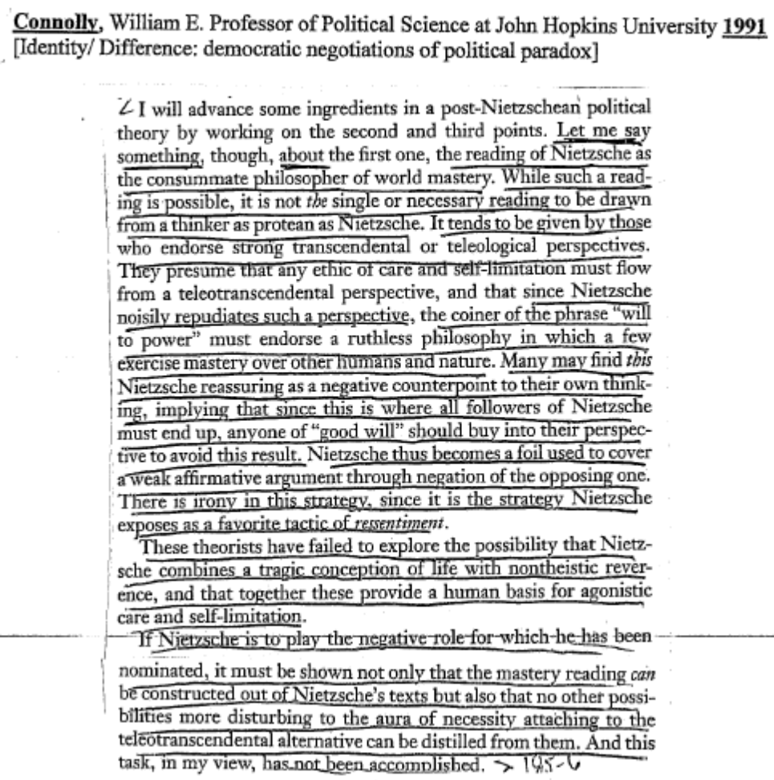

AT- Feminism

Nietzsche’s writing is key to overcome misogyny.

Barbara Helm, Institute for Philosophy, University of Tübingen, 2004, “Combating Misogyny?
Responses to Nietzsche by Turn-of-the-Century German Feminists”, The Journal of Nietzsche Studies 27 (2004) 64-84, ProjectMuse

Today, debates over essentialism versus anti-essentialism or difference versus equality are still unresolved. Gender dualism continues to bear risks, but today's feminists may find it easier to resist such dangers. With reference to Nietzsche, feminists are cautiously reconstructing the relationship between "woman" and "mother." 112 Concepts like sex, maternity, equality, and difference [End Page 76] have themselves become objects of feminist scrutiny. Foucault's anti-essentialist genealogical writing, inspired by Nietzsche, has contributed much to overcoming "sexist" traps. 113 Misogynous traces in Nietzsche's reception by contemporary women may advise today's feminists to approach his philosophy with caution. Yet, as Lynne Tirrell suggests, his writings may also "contain the seeds of a deconstruction of that misogyny." 114
AT: Exclusion Bad- It’s Inevitable

Exclusion is inevitably and becomes a necessary evil.

Daniel Conway, Professor and Department Head 19th Century Philosophy at Texas A&M, 1997, Nietzsche and the Political, pg. 37

Nietzsche thus views the practice of exclusion as an inescapable element-a “necessary evil,” as it were-of political legislation in any regime. In order for a society to produce a few whole human beings, it must legislate and enforce the fragmentation of countless others. Only by virtue of this exclusion is culture-an artificial subsystem sheltered within the indifferent economy of Nature-possible at all. He thus insists that
“the greatest of all tasks, the attempt to raise humanity higher, includ[es] the relentless destruction of everything that [is] degenerating and parasitical? (EH IV: 4). It is simply the nature of politics, he believes, that all regimes must practice exclusion, whether or not they do so knowingly and resolutely. Despite their visceral aversion to Manu’s grisly decrees, modern lawgivers are no more at liberty to dispense with political exclusion than to reprise his specific practice of it. The morality of taming too practices a form of exclusion, insofar as it forces all higher, singular types to lie in a Procrustean bed of its own mediocre design (TI 1X: 43); it too justifies its exclusionary practices by appealing to a sustaining myth, that of “equal rights for all” (CW 7).

AT- Your Evil

In order to perfect ourselves we must first dare to stand beyond good and evil- and free ourselves from conformity.

Daniel Conway, Professor and Department Head 19th Century Philosophy at Texas A&M, 1997, Nietzsche and the Political, pg.
Page 57

A formidable obstacle to this project of moral perfectionism lies, in fact, in the difficulty involved in undertaking an honest inventory of one’s native endowment of virtues and faculties. Those who would perfect themselves must first dare to stand beyond good and evil, for the conventional moral standpoint available to them will invariably discount their richest stores of affect, passion and fantasy. They will be urged to perfect themselves in the virtues and talents that constitute a conventional definition of “goodness,” regardless of any natural affinities or predilections they may or may not possess. Those who would remain true to their ownmost selves must consequently free themselves first from the constraints of convention and conformity.

AT- Util

Reject the utilitarian framework because of its construction of universal morals.

Jonny Anomaly, Assistant Professor of Philosophy at Ithaca College, 2005, “Nietzsche's Critique of Utilitarianism”, http://muse.jhu.edu/journals/journal_of_nietzsche_studies/v029/29.1anomaly.html

Nietzsche often connects the alleged universality (as opposed to the Kantian universalizability) requirement for morality with what he takes to be distinctively English morality. Indeed, one of the more striking wars Nietzsche wages against utilitarian morality might be characterized as a rebellion against English moral imperialism. He warns that although "morality in Europe today is herd animal morality," it is "only one kind of human morality beside which, before which, and after which many other, above all higher, moralities are possible" (BGE 202). In The Gay Science, Nietzsche associates the philosophical tendency to reify moral doctrines that serve a localized and often transitory function into practical principles that are universally and timelessly binding with the vanity of English genealogists: "These historians of morality (mostly Englishman) do not amount to much.... Their usual mistaken premise is that they affirm some consensus of the nations, at least of the tame nations, concerning certain principles of morals, and then they infer from this that these principles must be unconditionally binding also for you and me" (GS 345). Nietzsche elaborates this point elsewhere with specific reference to utilitarians:
Ultimately they all want English morality to prevail: inasmuch as mankind, or "the general utility," or "the happiness of the greatest number," no! the happiness of England would best be served; they would like with all their might to prove to themselves that to strive after English happiness, I mean after comfort and fashion ... indeed that all virtue there has ever been on earth has consisted in just such a striving. 31
(BGE 228)
In criticizing the English attempt to impose its provincial moral principles on all people, Nietzsche implicitly condemns every attempt to generate a universal criterion of morality as a contrivance arising from the widespread desire for a comprehensive moral standard. Nietzsche observes, "[E]verywhere today the goal of morality is defined in approximately the following way: it is the preservation and advancement of mankind; but this definition is an expression of the desire for a formula, and nothing more" (D 106). The need for a formula is a precarious psychological quirk, not a justification for requiring universality of any possible moral theory. On this interpretation, Nietzsche objects not to the theoretical structure of utilitarianism, but rather to the utilitarian aspiration to universalize its principles by grounding them in something more than the contingent needs of a particular group.32
AT- Util

Their utilitarian framework is just imposed suffering prevention- which is impossible to apply the framework fairly amongst people.

Friedrich Nietzsche, not a man but dynamite, 1886, Beyond Good and Evil, numb 228

I hope to be forgiven for discovering that all moral philosophy hitherto has been tedious and has belonged to the soporific appliances—and that “virtue,” in my opinion, has been MORE injured by the TEDIOUSNESS of its advocates than by anything else; at the same time, however, I would not wish to overlook their general usefulness. It is desirable that as few people as possible should reflect upon morals, and consequently it is very desirable that morals should not some day become interesting! But let us not be afraid! Things still remain today as they have always been: I see no one in Europe who has (or DISCLOSES) an idea of the fact that philosophizing concerning morals might be conducted in a dangerous, captious, and ensnaring manner—that CALAMITY might be involved therein. Observe, for example, the indefatigable, inevitable English utilitarians: how ponderously and respectably they stalk on, stalk along (a Homeric metaphor expresses it better) in the footsteps of Bentham, just as he had already stalked in the footsteps of the respectable Helvetius! (no, he was not a dangerous man, Helvetius, CE SENATEUR POCOCURANTE, to use an expression of Galiani). No new thought, nothing of the nature of a finer turning or better expression of an old thought, not even a proper history of what has been previously thought on the subject: an IMPOSSIBLE literature, taking it all in all, unless one knows how to leaven it with some mischief. In effect, the old English vice called CANT, which is MORAL TARTUFFISM, has insinuated itself also into these moralists (whom one must certainly read with an eye to their motives if one MUST read them), concealed this time under the new form of the scientific spirit; moreover, there is not absent from them a secret struggle with the pangs of conscience, from which a race of former Puritans must naturally suffer, in all their scientific tinkering with morals. (Is not a moralist the opposite of a Puritan? That is to say, as a thinker who regards morality as questionable, as worthy of interrogation, in short, as a problem? Is moralizing not−immoral?) In the end, they all want English morality to be recognized as authoritative, inasmuch as mankind, or the “general utility,” or “the happiness of the greatest number,”—no! the happiness of ENGLAND, will be best served thereby. They would like, by all means, to convince themselves that the striving after English happiness, I mean after COMFORT and FASHION (and in the highest instance, a seat in Parliament), is at the same time the true path of virtue; in fact, that in so far as there has been virtue in the world hitherto, it has just consisted in such striving. Not one of those ponderous, conscience−stricken herding−animals (who undertake to advocate the cause of egoism as conducive to the general welfare) wants to have any knowledge or inkling of the facts that the “general welfare” is no ideal, no goal, no notion that can be at all grasped, but is only a nostrum,—that what is fair to one MAY NOT at all be fair to another, that the requirement of one morality for all is really a detriment to higher men, in short, that there is a DISTINCTION OF RANK between man and man, and consequently between morality and morality. They are an unassuming and fundamentally mediocre species of men, these utilitarian Englishmen, and, as already remarked, in so far as they are tedious, one cannot think highly enough of their utility. One ought even to ENCOURAGE them, as has been partially attempted in the following rhymes
Aff- Death Worse

There’s no Ubermensch post extinction.
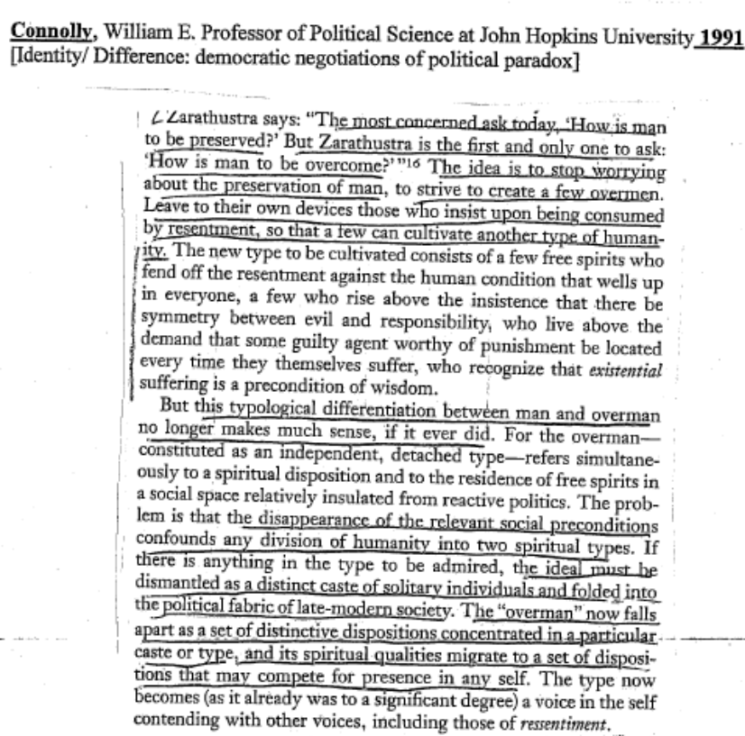
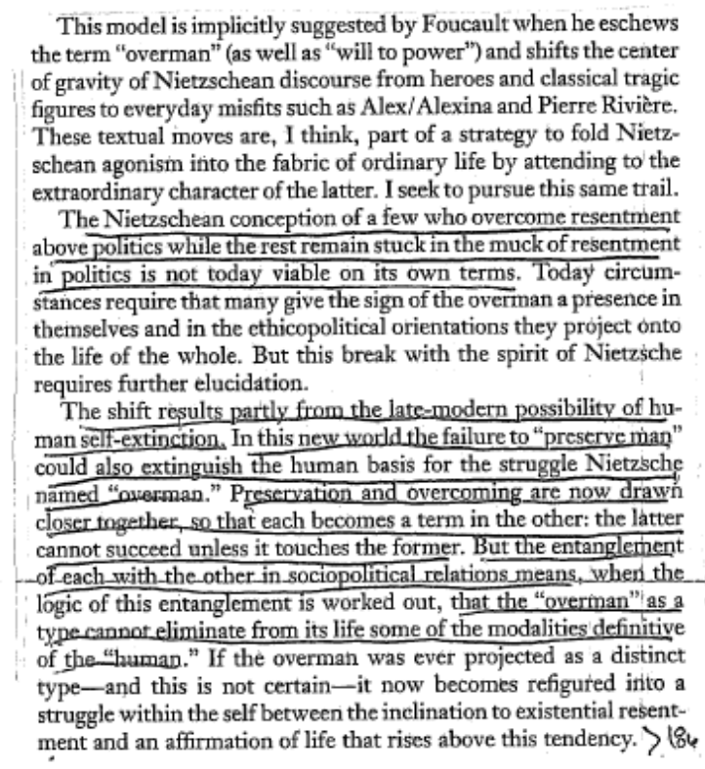
Aff- Nietzsche = Genocide

Nietzsche’s philosophy is used to justify mass slaughter.

Christopher Simpson, 1995, “The Splendid Blond Beast”, http://www.thirdworldtraveler.com/Genocide/SplendidBlondeBeast.html

Friedrich Nietzsche called the aristocratic predators who write society's laws "the splendid blond beast" precisely because they so often behave as though they are beyond the reach of elementary morality. As he saw things, these elites have cut a path toward a certain sort of excellence consisting mainly of the exercise of power at the expense of others. When dealing with ordinary people, he said, they "revert to the innocence of wild animals.... We can imagine them returning from an orgy of murder, arson, rape and torture, jubilant and at peace with themselves as though they had committed a fraternity prank-convinced, moreover, that the poets for a long time to come will have something to sing about and to praise.'' Their brutality was true courage, Nietzsche thought, and the foundation of social order.
Today genocide-the deliberate destruction of a racial, cultural, or political group-is the paramount example of the institutionalized and sanctioned violence of which Nietzsche spoke. Genocide has been a basic mechanism of empire and the national state since their inception and remains widely practiced in "advanced" and "civilized" areas. Most genocides in this century have been perpetrated by nation-states upon ethnic minorities living within the state's own borders; most of the victims have been children. The people responsible for mass murder have by and large gotten away with what they have done. Most have succeeded in keeping wealth that they looted from their victims; most have never faced trial. Genocide is still difficult to eradicate because it is usually tolerated, at least by those who benefit from it.

